Energy Transformation
Energy transformation= Where ____________ changes from one type of __________ to another.
We can show the energy transformations in an energy flow diagram
Types of energy that you can use to make the flow diagrams are, chemical, electric, light, heat, sound, solar, kinetic.
Situation | Picture | Energy flow diagram
 |  | Heat  Chemical  Light
Electric light | 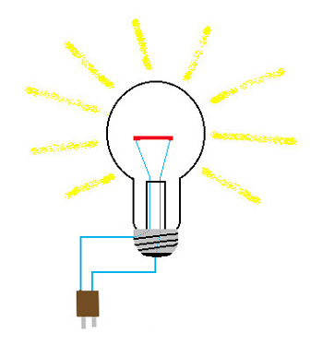 | Electric
toaster | 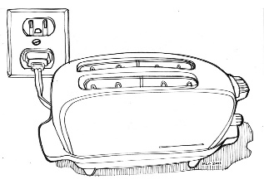
Mobile phone | 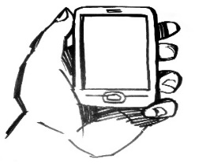
Solar panel  Charging a battery  And  Being used to  Boil a  kettle | 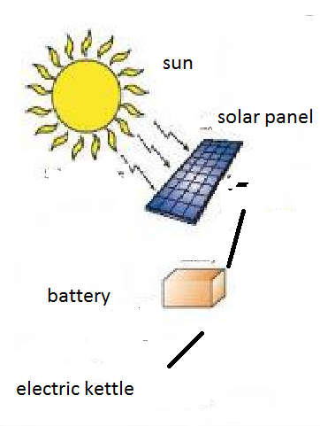
Lawn mover | 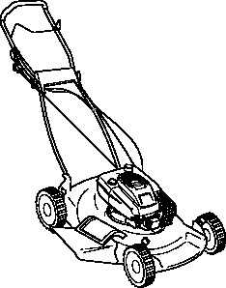

Motor car

Petrol stores energy chemical potential

Petrol burns heat

Engine moves kinetic

Heat sound

Car moves kinetic

Did all the energy from the store of energy in the petrol get used to move the car?

What else did the stored energy get used for?

Were these other forms of energy made very useful?

We call the energy that is used from the petrol the INPUT ENERGY.
We call the useful energy of the car moving the OUTPUT ENERGY.
The non-useful heat and sound energy are a waste of energy.
Energy efficiency is a measure of how much of in the input energy gets changed into USEFUL OUTPUT ENERGY.
Energy efficiency = useful energy output X 100
Energy input

We can calculate the energy efficiency of different things.
For example a petrol car uses 10,000kj of energy to get 2,500kj of forward kinetic movement.
What is its efficiency?
Energy efficiency = useful energy output x 100
Energy input

Energy efficiency = 2,500 X 100
10,000

= 25%

Complete this table
Situation | Energy input  (kj) | Useful energy output  (kj) | calculation | Efficiency  (%)
Boy riding a bike | 1000 | 950 | ________ x 100
Petrol car | 20,000 | 5,000 | ________ x 100
Diesel car | 20,000 | 7,000 | ________ x 100
Steam train | 100,000 | 40,000 | ________ x 100

Comparing the Energy Efficiency of Different types of Transport


Different types of Transport

